  Faculté des arts et sciences  Année universitaire 2012-2013 | Droit des relations internationales  INT-6050  Trimestre d’hiver 2013  Professeur : Daniel Turp  Auxiliaire d’enseignement : François-Xavier Saluden
COURRIEL N^{O} 4bis
(15 février 2013)
Chers étudiants, chères étudiantes,

Juste un court mot pour vous saluer de New York où je suis arrivé en fin d'après-midi hier en prévision de la première de Parsifal de Richard Wagner au Metropolitan Opera de New York. Et si le coeur vous en dit, je vous invite à visionner deux extraits de la répétition générale de cette production dont la mise en scène a été confiée au Québécois François Girard (qui est aussi un cinéaste et qui a réalisé trois très beaux films Thirty Short Films about Glenn Gould, Le Violon Rouge et Soie). Vous pouvez visionner ces deux extraits aux adresses suivantes : http://www.youtube.com/watch?v=qhBGZlcjn84 (Jonas Kaufmann- Parsifal) http://www.youtube.com/watch?v=j3gJvyNrK88 (René Pape-Gurnemanz). Et vous pourrez aussi entendre François Girard parler de l'opéra à l'adresse suivante : http://www.youtube.com/watch?v=5XQBVtsKjGA.

Et s'agissant de l'actualité du droit international, les cyber-attaques font encore parler d'elles car, comme vous le constaterez en lisant un article publié aujourd'hui et que je joins en annexe ci-après, l'Iran souhaite qu'un instrument international soit adopté en la matière. Cela devrait particulièrement intéresser votre camarade de classe et mon étudiant Hojjat Salehi !

Vous êtes entre bonnes mains avec FX et je souhaite bon cours à vous tous et toutes !

Votre professeur,

Daniel Turp

ANNEXE

Iran calls for new international legal instrument against cyber attacks
Source électronique : http://www.presstv.ir/detail/2013/02/15/289030/iran-urges-rules-against-cyber-attacks
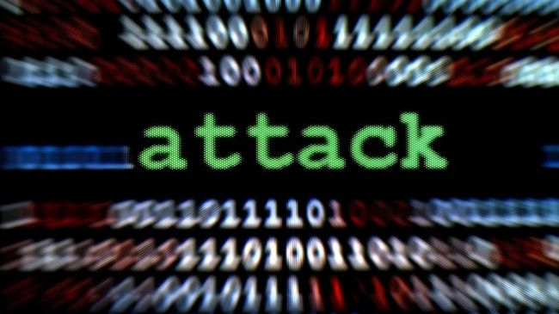
Iran calls for a new international legal instrument to counter trans-border cyber attacks across the world.
Fri Feb 15, 2013 7:5AM GMT
Iran has underlined the need for a new international legal instrument to counter the increasing wave of cross-border cyber attacks in the world.
Alireza Miryousefi, the head of the press office for the Iranian mission to the UN, and Hossein Gharibi, the counselor of the mission, said in an opinion piece published on the Christian Science Monitor on Thursday that the world “needs a new international legal instrument on cyberspace, in light of the new waves of trans-border cyber attacks that have become a disturbing aspect of international relations in the 21st century.” The two Iranian diplomats also described cyber attacks as a global “concern” and a “new phenomenon in the history of modern warfare,” which “threaten global peace and security and require new norms under international law and principles of the UN Charter.”
The article stressed the need for a “collective international effort” to combat the so-called digital battlefield. As the current chair of the Non-Aligned Movement and a responsible member of the international community whose important industrial and economic sectors have been targeted by “state-sponsored” cyber attacks, Iran is strongly committed to the goal of reinforcing international binding legal rules dealing with cyber security, the Iranian diplomats stated.
They said that Iran has never conducted a cyber attack against any country, including the United States, or retaliated such “illegal” moves, while Washington supported cyber offensives like the Stuxnet attack against the Islamic Republic
Iran has been the target of several cyber attacks over the past few years.
In June 2012, a report by the Washington Post said the US and the Israeli regime had cooperated in creating the computer virus Flame to spy on Iran. US National Security Agency, the CIA and the Israeli military worked together to create the Flame virus, the paper added.
In addition, the New York Times also revealed in the same month that US President Barack Obama secretly ordered a cyber attack with the Stuxnet computer virus against Iran to sabotage the country’s nuclear energy program.

